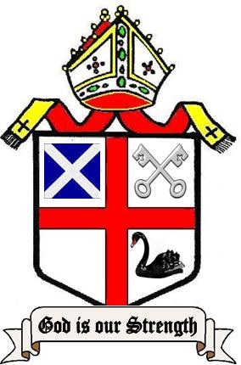
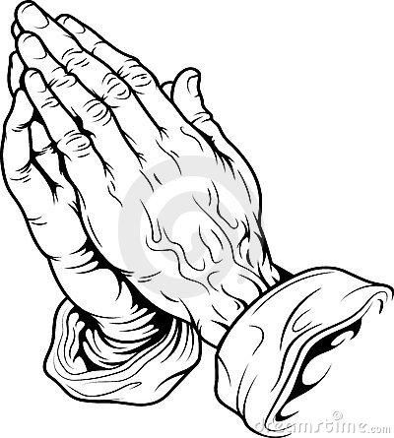
A PRAYER DIARY
FOR THE PARISHES OF
THE TRADITIONAL
ANGLICAN CHURCH IN
WESTERN AUSTRALIA
October 2022
-------------------------------------------------------------------------------------------

MY DAILY PRAYERS

In the Name of the Father and of the Son and of the Holy Spirit. Amen.

Our Father which art in ….

God is our hope and strength: a very present help in trouble

If we say that we have no sin, we deceive ourselves, and the truth is not in us: but, if we confess our sins, He is faithful and just to forgive us our sins, and to cleanse us from all unrighteousness

I confess to Almighty God, Father, Son and Holy Spirit that I have sinned in thought, word and deed, through my own grievous fault. Wherefore I pray God to have mercy upon me.

May Almighty God grant unto me pardon and remission for all my sins, true repentance and amendment of life, and the grace and comfort of the Holy Spirit. Amen.

Lord Jesus, Bless Your Church in Western Australia, bestow grace on our priests and give what is needed so the Gospel may be faithfully proclaimed.

Blessed Lord, who hast caused all Holy Scriptures to be written for our learning: Grant that we may in such wise hear them, read, mark, learn, and inwardly digest them, that by patience, and comfort of Thy holy word, we may embrace, and ever hold fast the blessed hope of everlasting life, which Thou hast given us in our Saviour Jesus Christ. Amen.

1 Saturday
For Spiritual growth through daily Prayer & Bible reading
Centaine Scott; Michelle Scott

2 Trinity XVI
For those who have no one to pray for them
Mairi Scott; Patricia Scott

3 Monday
For those who faithfully serve the Lord Jesus Christ
Marion Beard; Greg Beard

4 Tuesday
That we may bravely contend for the Christian faith
Angeline Teh; Jeanette Teh
Nina Babic; Mia Babic

5 Wednesday
For Bp David and the members of our Diocesan Council
Fr Brian Tee; Miems Tee

6 Thursday
That we may show love and care for all people
Natalie Baldwin; Stacey Baldwin
Thomas Baldwin

7 Friday
Pray for Fr Brian and for Ken and Keith our Subdeacons
Andrew Veal; Bronwyn Veal
Abigail; Levi; William; Sofia

8 Saturday
That we may be protected from the Covid 19 virus
Patricia & Ian Campbell Clause

9 Trinity XVII
That we may use the world’s resources wisely and carefully
Geoff Pollard; Pam Pollard

10 Monday
That those men God calls may offer themselves for ordination
Fr Robert Burn; Joan Burn

11 Tuesday
Pray for the people of Ukraine and that the conflict may cease
Anna Vaness; Patricia Rigby

12 Wednesday
For a spirit of Love and Peace for all Nations and People
Dougal Burton; Beth Burton
William Burton; Amelia Burton

13 Thursday
For the homeless and those who try to support them
Peter Emmens; Joshua Burton

14 Friday
Pray for the Traditional Church throughout the world
Marie Bolt; Shelley Dixon

15 Saturday
That Australia’s cost of living problems may be solved
Helen Martin; Pat Daniel

16 Trinity XVIII
For Kindergartens, Schools and Universities and all in education
Mary Hoffman; Susan Morisey

17 Monday
That the Holy Spirit will draw us closer to Jesus our Lord
Deirdre O’Brien; Keith O’Brien

18 St Luke the Evangelist
For faithfulness to God’s truths as revealed in the Bible
Bp John Keep; Jennifer Rourke

19 Wednesday
For the members of our Management Committee
Brian Daniels; Robyn Daniels

20 Thursday
For our parishes of St Andrew and St Peter
Ken Krachler; Stuart Krachler

21 Friday
That all people may experience God’s love, joy and peace
Brian LeFaever; Eileen LeFaever

22 Saturday
The Parish of the Resurrection, Edmonton, Canada
Shirley McFarlane
Barbara Reynolds

23 Trinity XIX
Pray for Ukraine and for help as they renew their lives and homes
Pearl de Lang; Nancy Mollan

24 Monday
For our families and friends
Jennifer Newill; Denise Turner

25 Tuesday
That we may welcome the living Christ into our hearts
Iain Scott; Neville McPherson

26 Wednesday
Give thanks and Pray for the Faithful members of the TAC
Centaine Scott; Michelle Scott

27 Thursday
For courage to speak openly about our faith and our church
Mairi Scott; Patricia Scott

28 St Simon and St Jude
Apostles and Martyrs
For the conversion of the faithless throughout the world
Marion Beard; Greg Beard

-------------------------------------------------------------------------------------------
29 Saturday
That we may open our hearts to our Risen Lord
Angeline Teh; Jeanette Teh
Nina Babic; Mia Babic

30 Trinity XX
That the Church remains faithful
Fr Brian Tee; Miems Tee

31 Monday
For the Police, Paramedics, Firemen and Hospital Workers
Natalie Baldwin; Stacey Baldwin
Thomas Baldwin

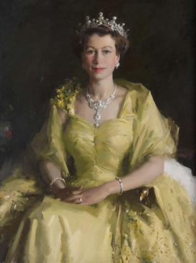
May Flights of Angels
Sing thee to thy Rest

Elizabeth II

By the Grace of God, of the United Kingdom of Great Britain and Northern Ireland and of her other realms and territories Queen,

1926 - 2022 Head of the Commonwealth,
Defender of the Faith.

We give thanks to God for our late Queen
May her late Majesty Rest in Peace and Rise in Glory

God save the King

